Assignment: Feature Engineering Using Snowflake and Feature Stores

1. Introduction to Feature Engineering
• Define feature engineering and explain its importance in machine learning.
Ans: Feature engineering is the process of transforming raw data into meaningful features that improve the performance of machine learning models. It involves creating, modifying, or selecting features to make patterns in data more accessible to ML algorithms.
Importance in Machine Learning:
- Enhances model accuracy by providing better inputs.
- Reduces training time and complexity.
- Helps models capture domain-specific knowledge.
- Ensures consistency between training and prediction data.
• Describe different types of feature engineering techniques (e.g., normalization, encoding, time-based aggregations).
Ans:
(i) Normalization / Scaling
- Purpose: Brings numerical features to a common scale, which helps ML models converge faster and perform better.
- Techniques:
Min-Max Scaling: Scales values between 0 and 1.
$$X_{\text{scaled}}=\frac{X-X_{\text{min}}}{X_{\text{max}}-X_{\text{min}}}$$
- Standardization (Z-score): Scales values to have mean = 0 and standard deviation = 1.
$$X_{\text{standard}}=\frac{X-μ}{σ}$$Example: Scaling amount values of transactions before feeding into a regression model.
(ii) Encoding Categorical Variables
- Purpose: Converts non-numeric categorical variables into numeric representations that ML models can use.
- Techniques:
- One-hot Encoding: Creates a binary column for each category.
- Label Encoding: Assigns a unique integer to each category.
- Target Encoding: Replaces categories with a statistic derived from the target variable (like mean target value).
Example: Transforming category = {“A”, “B”, “C”} into category_A, category_B, category_C.
(iii) Time-based Feature Engineering
- Purpose: Extracts meaningful features from dates or timestamps.
- Techniques:
- Extract day, month, year, weekday, or hour from timestamps.
- Create lag features: previous day/week/month value.
- Rolling/Moving averages: average over last N days.
Example: Computing the 7-day rolling average of sales per customer.
(iv) Aggregation Features
- Purpose: Summarizes information at group level to capture patterns.
- Techniques:
- Count: number of events per group.
- Sum, Mean, Max, Min: statistical aggregations for numeric columns.
Example: Total orders per customer or average order value per product category.
(v) Interaction Features
- Purpose: Combines multiple features to create new ones that capture relationships.
- Techniques:
- Multiply two features: amount * discount.
- Combine categorical variables: product_category + region.
Example: Interaction between age and income to predict spending behavior.
(vi) Feature Transformation / Mathematical Features
- Purpose: Apply mathematical functions to features to better represent relationships.
- Techniques:
- Logarithmic transformation: log(amount) to reduce skewness.
- Polynomial features: x², x*y for non-linear relationships.
Example: Using log of income to normalize highly skewed values.
(vii) Missing Value Handling / Imputation
- Purpose: Deals with incomplete data to prevent errors in ML models.
- Techniques:
- Fill with mean, median, or mode.
- Forward-fill or backward-fill for time series.
- Flag missing values with a separate binary feature.
Example: Filling missing age values with median age in the dataset.
2. Using Snowflake for Data Storage & Processing
• Explain how Snowflake is used for storing structured and semi-structured data.
Ans: Snowflake is a cloud-based data platform that acts as a data warehouse, allowing organizations to store, manage, and analyze large volumes of data. It supports both structured and semi-structured data efficiently using a single platform.
- Storing Structured Data
Structured data refers to data organized in rows and columns, like traditional relational databases.
Examples: Sales transactions, customer information, product inventory.
How Snowflake Handles Structured Data:
- Tables are created using SQL.
- Data types include STRING, INTEGER, FLOAT, DATE, BOOLEAN, etc.
- Supports ACID transactions for reliable operations.

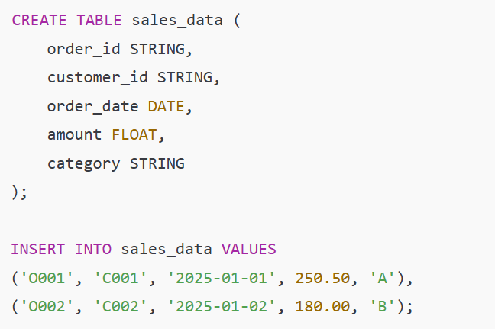

- Semi-Structured Data
Semi-structured data does not conform strictly to rows and columns but still contains tags or markers to separate elements.
Examples: JSON, XML, Avro, Parquet, ORC files.
How Snowflake Handles Semi-Structured Data:
- Uses a VARIANT data type to store semi-structured data directly.
- Supports nested objects and arrays, which can be queried using dot notation or flatten functions.
- Eliminates the need for pre-defining a rigid schema.
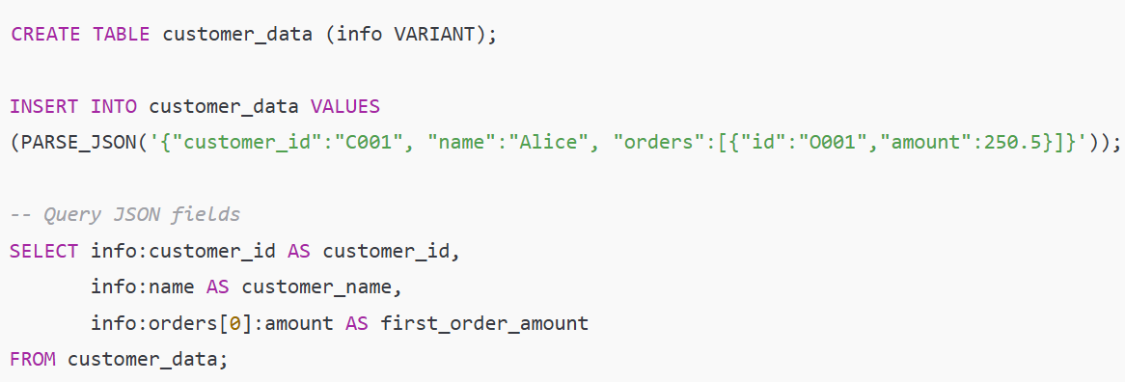
• Provide an example of SQL queries that extract and preprocess data in Snowflake.
- Extract Raw Data:
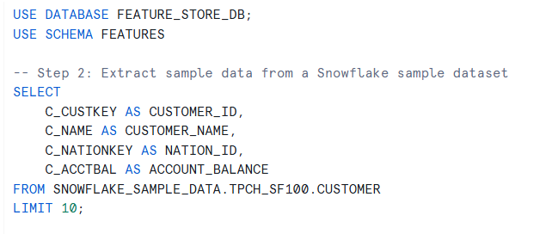

b) Preprocess data - Handle missing or invalid values Replace NULL balances with 0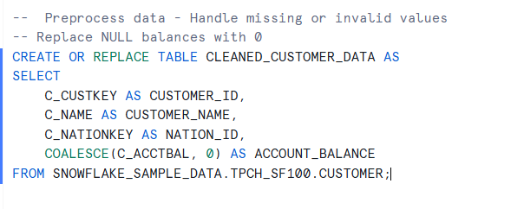

c) Feature engineering - Create aggregated features
Example: Average and total account balance per nation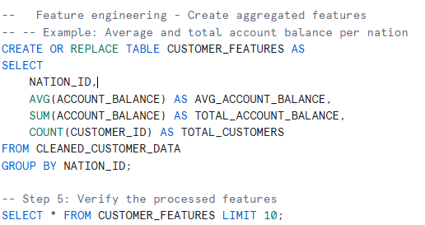

• Discuss how Snowflake integrates with ML pipelines.
(i) Snowpark Integration:
- Snowflake provides Snowpark, a developer framework for Python, Scala, or Java.
- Allows data transformation, feature engineering, and even training ML models directly within Snowflake without exporting data.
(ii) Feature Store Integration:
- Engineered features can be stored in Snowflake Feature Store and accessed for both offline training and real-time inference.
(iii) External ML Tool Integration:
  - Snowflake connects easily to ML frameworks like Scikit-learn, TensorFlow, PyTorch, and SageMaker.
  - Features can be exported via secure queries or accessed via Snowflake connectors for model training and prediction.
(iv) Benefits for ML Pipelines:
  - Single source of truth for features.
  - Reduces data movement and duplication.
  - Enables consistent, reproducible ML workflows.
3. Feature Store Concepts
• What is a Feature Store, and why is it needed?
Ans: A Feature Store is a centralized repository for storing, managing, and serving features used in machine learning models. It acts as a bridge between raw data and ML models, ensuring that features are consistent, reusable, and easily accessible for both training and inference.
Why Feature Stores are Needed:
- Consistency: Ensures that the same feature definitions are used during model training and prediction, preventing discrepancies that reduce model accuracy.
- Reusability: Features created once can be reused across multiple models and teams, saving time and avoiding duplication of effort.
- Scalability: Handles large volumes of features and supports real-time as well as batch access for ML pipelines.
- Simplified ML Pipelines: Centralizes feature engineering logic, making pipelines easier to maintain and deploy.
- Version Control: Tracks versions of features, which is essential for reproducibility and auditing.
Example:
Suppose multiple teams are building different models to predict customer churn. A feature like average_purchase_last_30_days can be computed once, stored in the Feature Store, and then used consistently across all models.
• Compare different feature stores (e.g., AWS Sage Maker Feature Store, Snowflake Feature Store, Databricks Feature Store).
Feature Store | Pros | Cons
AWS SageMaker Feature Store | • Tight integration with SageMaker ML pipelines.  • Supports real-time (online) and batch (offline) features.  • Managed service, scalable. | • AWS-specific ecosystem.  • Costs can be high for large-scale usage.
Snowflake Feature Store | • SQL-based, easy for teams familiar with Snowflake.  • Direct integration with Snowflake data warehouse.  • Supports both batch and streaming features. | • Limited ML tooling outside Snowflake ecosystem.  • Real-time streaming may require additional setup.
Databricks Feature Store | • Optimized for Spark and large-scale distributed data.  • Seamless integration with Databricks ML pipelines.  • Supports versioning and metadata tracking. | • Higher learning curve for beginners.  • Requires Databricks infrastructure.

4. Implementing Feature Engineering with Snowflake & Feature Store
• Extract: Use Snowflake SQL to fetch raw data.

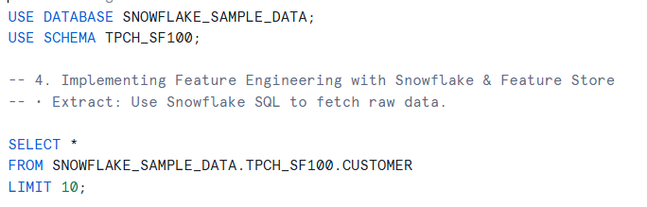

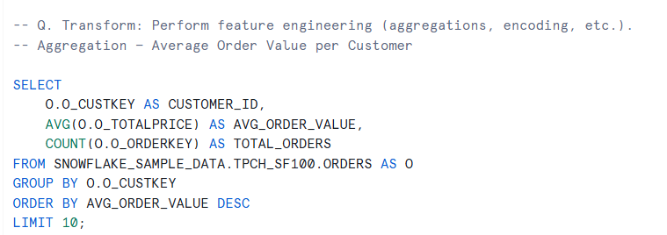
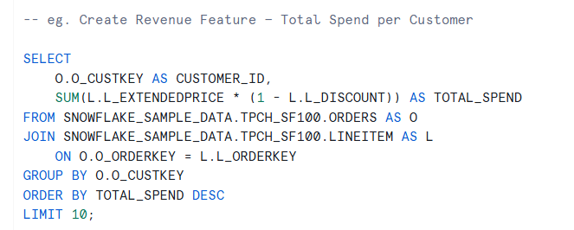
• Transform: Perform feature engineering (aggregations, encoding, etc.).
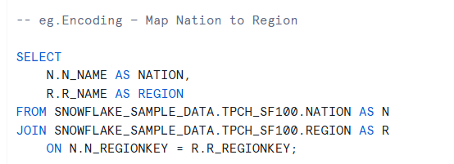
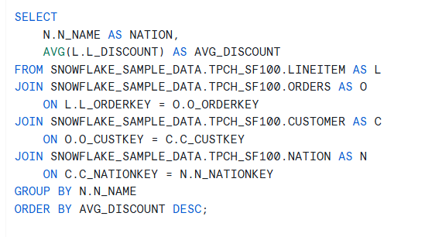

• Load into Feature Store: Explain how features can be stored in a Feature Store.
Ans: A Feature Store is a centralized repository for storing ML-ready features, enabling consistency, reusability, and versioning across models. Features are typically stored in a dedicated table within a database designed for feature management.
(i) Create a dedicated database and schema for the Feature Store
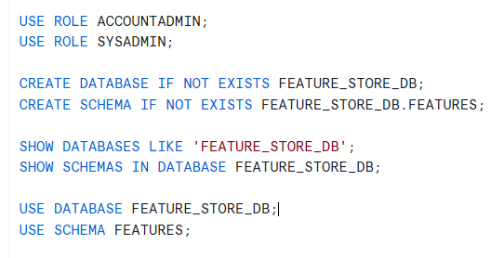

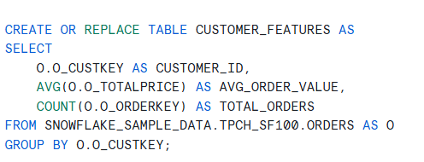
(ii) Create a Feature Store table with engineered features

• Access for ML: How can ML models retrieve features from the store?
Ans: ML models retrieve features from a Feature Store using APIs, SQL queries, or Feature Store SDKs. For training, features are fetched in batches to create a dataset with labels, and for real-time inference, features are accessed online with low latency. This ensures models always use consistent and up-to-date feature values.

5. Practical Task
• Connect to Snowflake, extract some sample data, and perform feature engineering.
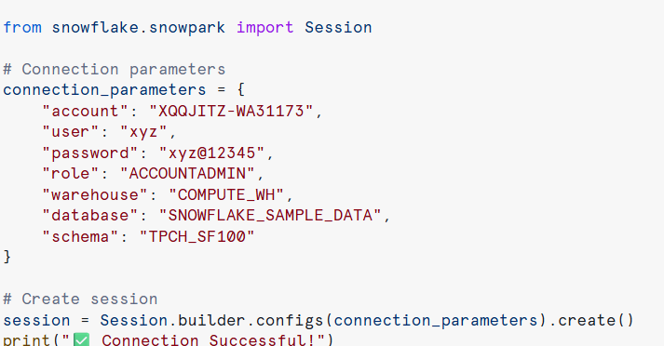

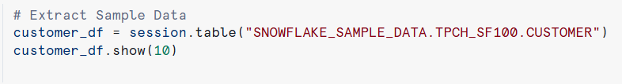

Output:
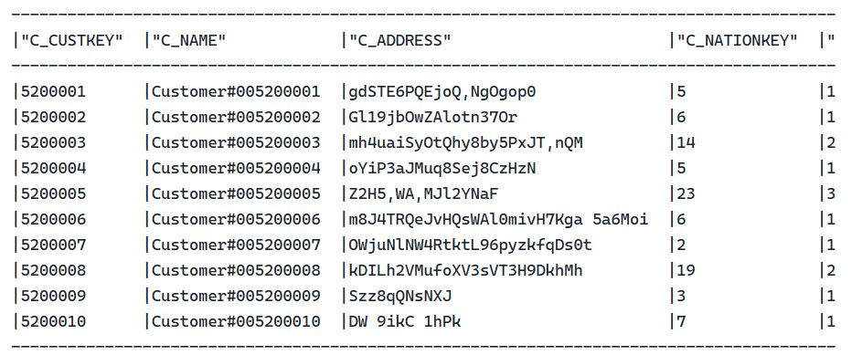

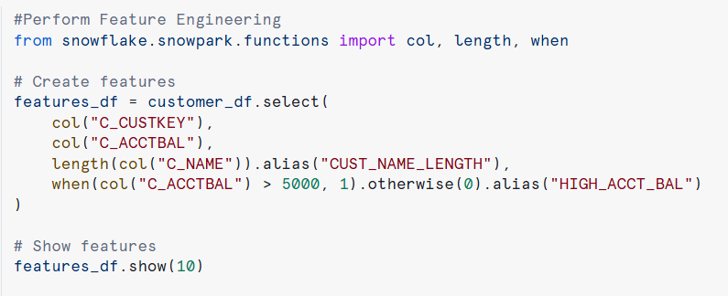

Output:
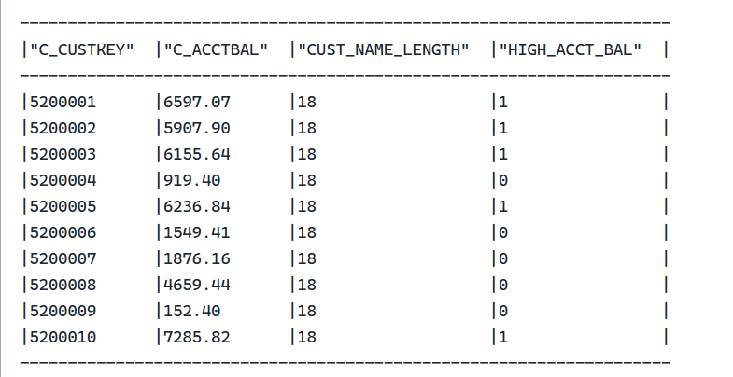

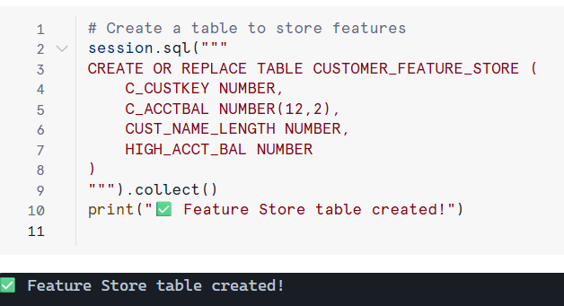
• Store the features in a Feature Store (e.g., Snowflake FS, Databricks FS, or AWS Feature Store).

• Retrieve features and use them for model training.

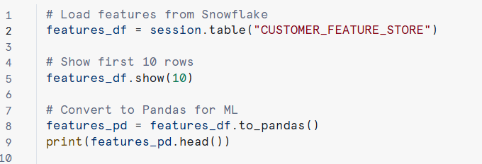

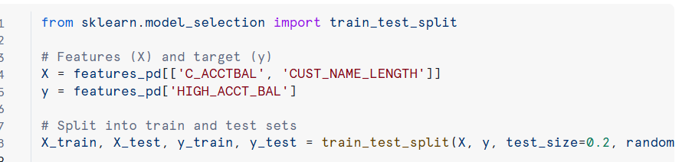

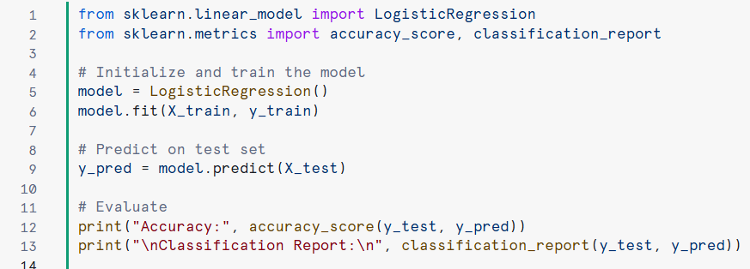

Github Link: https://github.com/Diwakar124/Grafyn---AL-Ml-Assignment/tree/main

